**Assignment 3.2**

**Associated Data Files**

This Data set is about Olympics. You can download the data set from the below link:

<https://drive.google.com/open?id=0ByJLBTmJojjzV1czX3Nha0R3bTQ>

CREATE DATABASE olympics;

USE OLYMPICS;

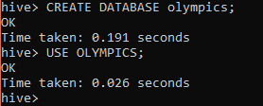

CREATE TABLE IF NOT EXISTS olympic_data (athlete String, age int, country String, the_year int, closing_date string, sport String, gold int, silver int, bronze int, total_medals int) ROW FORMAT DELIMITED FIELDS TERMINATED BY '\t';

LOAD DATA LOCAL INPATH '/home/acadgild/olympix_data.csv' INTO TABLE olympic_data;





1. **Write a Hive program to find the number of medals won by each country in swimming.**

SELECT country,SUM(total_medals) FROM olympic_data WHERE sport = 'Swimming' GROUP BY country;



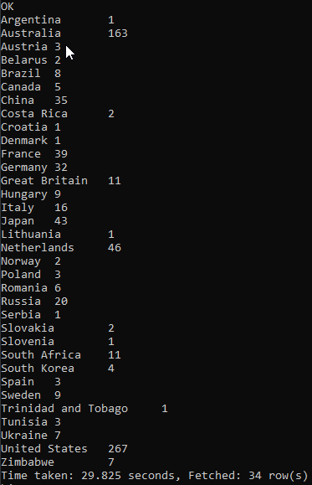

1. **Write a Hive program to find the number of medals that India won year wise.**

SELECT the_year, SUM(total_medals) FROM olympic_data WHERE country = 'India' GROUP BY the_year;



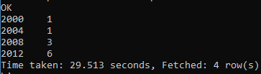

1. **Write a Hive Program to find the total number of medals each country won.**

SELECT country, SUM(total_medals) FROM olympic_data GROUP BY country;



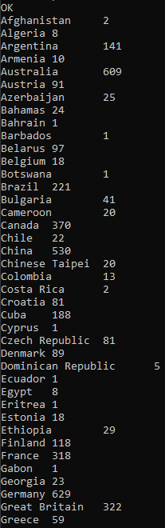

1. **Write a Hive program to find the number of gold medals each country won.**

SELECT country, SUM(gold) FROM olympic_data GROUP BY country;



